The Effect of the Following Events On the Market for Sweatshirts
Student’s Name
Institutional Affiliation

The Effect of the Following Events On the Market for Sweatshirts
- A hurricane in South Carolina damages the cotton crop
The raw materials for clothes manufacturing is the cotton. With focus on the hurricane that damaged the cotton plantations in South Carolina, the demand of cotton will be high whereas the availability of Cotton will go down due to the destruction by hurricane. Due to low level of production of cotton, the price will automatically go up thus resulting to increase in the production of coast of the sweatshirts. The producers will reduce the rate at which they are supplying the markets while the price at which they are supplying will go up. As result the supply curve will move to the left while the demand curve remains constant.
The supply of sweatshirts will decrease to the left as indicated in the figure below, that is from S1S1 to S2S2 whereas the quantity will also decrease from Q1 to Q2. The only increase that will be seen is the increase in the price of sweatshirt from P1 to P2.

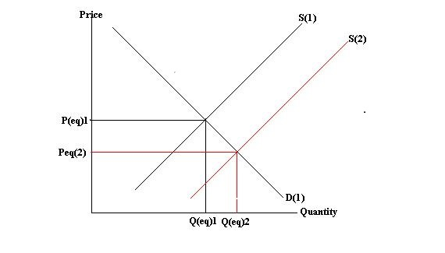

2.The price of leather jackets falls
Leather jackets are substitutes of the sweatshirts. And the two are produced differently with different materials. Them being substitutes, reduction in the quantity of one will result to an increase in the supply of the other. This goes to the price to as the price of one increases, the price of the other decreases. A fall in the demand of sweatshirt causes a leftward drag of the demand curves from D1D1 to D2D2 whereas the supply curves remains constant. A fall in the price from P1 to P2 and a decrease in quantity from Q1 to Q2
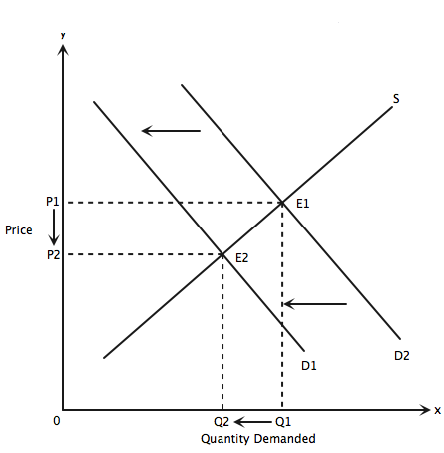
3. All colleges require morning exercise in appropriate attire.
Having an appropriate attire, will increase the demands for the sweatshirt whereas the supply remains constant. With an increase in the price, increase in the price will also be noted. The demand curve will shift to the right that is from D1D1 to D2D2 as a result, the price will also increase from P1 to P2, and as well as the amount of the quantity will also increase from Q1 to Q2.
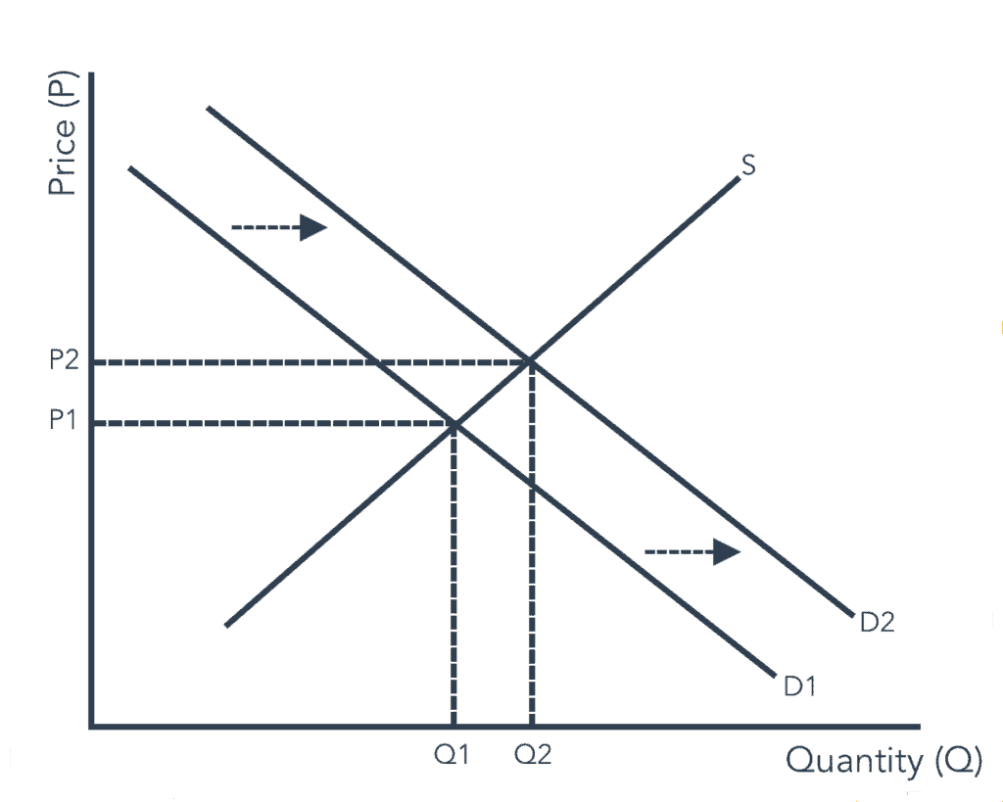
4. New knitting machines are invented.
Invention of new knitting machines, is as an improvement in the level of technology. As well-known machine increase the rate of production thus resulting into more sweatshirt being produced. The supply will increase for the sweatshirt due to the high level of production. Make more sweatshirts available in the market, the price automatically will fall.
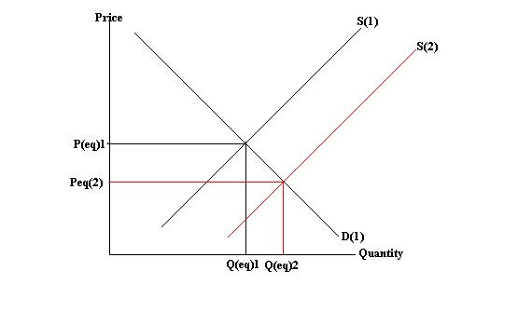

References
Blanchard, O. J., & Quah, D. (1988). The dynamic effects of aggregate demand and supply disturbances.

